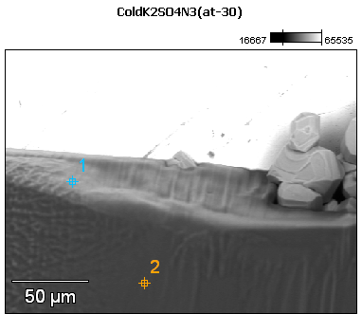

Image Name: ColdK2SO4N3(at-30)

Image Resolution: 512 by 384

Image Pixel Size: 0.45 µm

Acc. Voltage: 12.0 kV

Magnification: 550

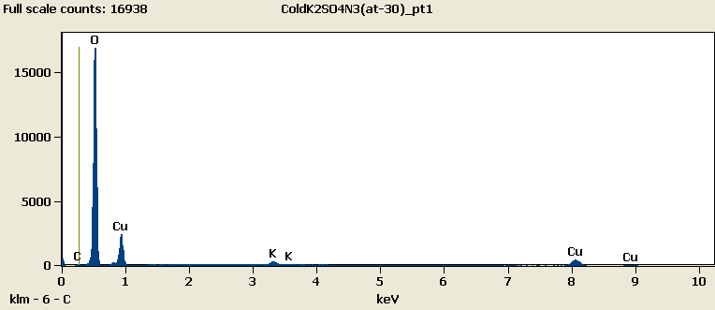

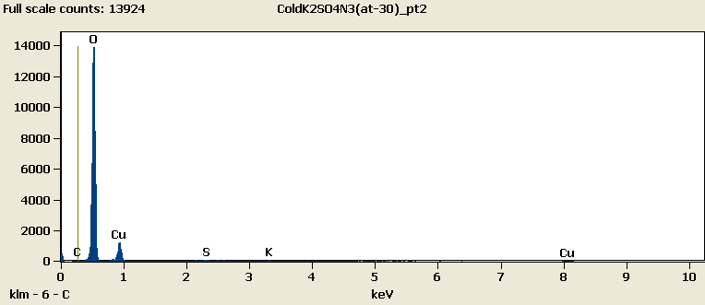

Weight %

|  |
| --- |
| ***ColdK2SO4N3(at-30)_pt1-No Data.*** |
| ***ColdK2SO4N3(at-30)_pt2-No Data.*** |

Weight % Error (+/- 1 Sigma)

|  |
| --- |
| ***ColdK2SO4N3(at-30)_pt1-No Data.*** |
| ***ColdK2SO4N3(at-30)_pt2-No Data.*** |

# Cations

|  |
| --- |
| ***ColdK2SO4N3(at-30)_pt1-No Data.*** |
| ***ColdK2SO4N3(at-30)_pt2-No Data.*** |